Instrument Test Plan

Summary
There are currently three instruments within the orbit system, which are connected to a master SIU device. The master SIU acts as the local instrument master control, sending instructions and receiving data via the OmmoCom network. The three current instruments are:
- Instrument tracker.
- Patient reference.
- Pointer.

The System
Each of these types of instruments have a different number and types of sensors that need to be accessed via the OmmoCom interface. Putting all of the sensors and MCUs into a theoretical maximally configured system, we get the full load-out below. This is just a composite of all possible sensors and not an actual instrument type.

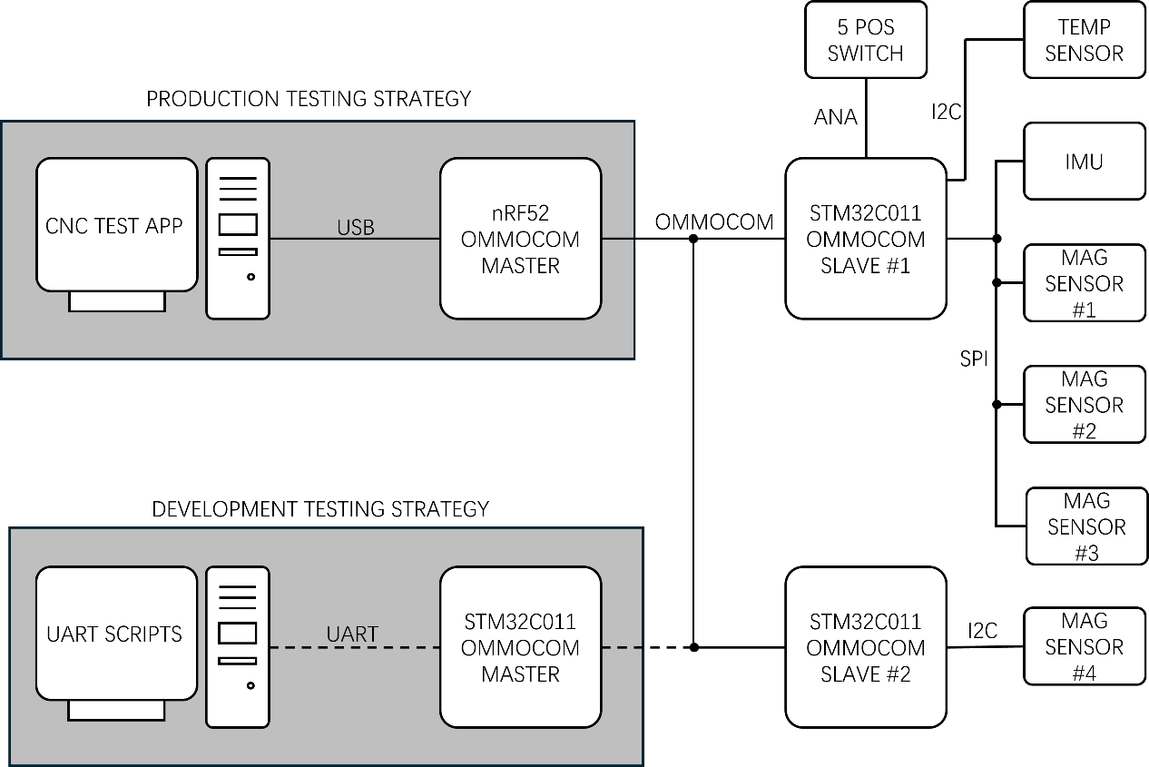

Process
The eventual aim would be to have CNCTestApp as the test control point, this would allow infield debugging of instruments and the sensors in a convenient way. Currently this feature set is not available on that application. To facilitate testing during development, it is proposed that an alternative approach is adopted. In this development process, it is proposed to use an STM32C011 EVK to act as an OmmoCom master node, in place of the master SIU. This OmmoCom master would take test scripts from a PC over a standard USB/UART interface and process the test scripts for each sensor individually. This will be a fairly manual process but would allow system level testing.

Scope
This document is only defining the process of the instrument Test plan from the firmware perspective and for the development system.

Tasks
There are a number of tasks that need to be completed before the test system is ready for use. The following firmware modules need to be completed:

Firmware Module | STM32C011 OmmoCom Master | STM32C011 OmmoCom Slave | Incremental Time (days)
Create test mode | YES | YES | 3 days
Temperature sensor driver |  | YES | 4 days
2nd co-processor firmware |  | YES | 5 days
Mag sensor #4 driver |  | YES | 6 days
Define test mode functions | YES | YES | 5 days
Create UART scripts | YES

